Replace and modernize legacy VPN architectures with a cloud-native Zscaler Zero Trust solution to reduce attack surface and lateral movement.
College name: KARUPPANNAN MARIAPPAN COLLEGE
College Code: bru3s
Team ID : SWTID-2026-1879

Team Size : 4

Team Leader : SANTHIYA T
Email: ammukiddo63@gmail.com

Team member : APARNA V
Email: aparnav0204@gmail.com

Team member : KARTHIKA P
Email: karthikamidhu377@gmail.com

Team member : PASUPATHI T
Email: pasu00044@gmail.com

Project details Title:

Replace and modernize legacy VPN architectures with a cloud-native Zscaler Zero Trust solution to reduce attack surface and lateral movement.

In response to the evolving threat landscape and the dissolution of the traditional network perimeter, this project initiates a fundamental shift in our security architecture. We will be decommissioning our legacy VPN infrastructure, which relies on an outdated castle-and-moat model that grants excessive network access and is vulnerable to lateral threat movement. To replace it, we are adopting a cloud-native, Zero Trust approach powered by Zscaler. This new architecture is built on the principle of "never trust, always verify," ensuring that users are connected to applications, not to the network. By making applications invisible to the internet and establishing direct, secure user-to-app connections, we will drastically reduce our attack surface. This modern solution eliminates the risk of lateral movement, as threats can no longer traverse a flat network. Furthermore, it provides a superior, high-performance experience for our hybrid workforce, decoupling security from data center backhauling. The transition to Zscaler will not only bolster our security posture but also enhance agility and reduce the operational overhead associated with managing legacy hardware. This initiative is a critical step in future-proofing our organization against sophisticated cyber threats.

Abstract:

This project details the strategic migration from a legacy Virtual Private Network (VPN) infrastructure to a cloud-native Zero Trust Network Access (ZTNA) solution provided by Zscaler. The primary driver for this initiative is the fundamental inadequacy of traditional VPNs in the modern threat landscape. Legacy architectures operate on a "connect first, verify later" model, granting users broad access to the corporate network and, consequently, creating a significant risk of lateral movement by malicious actors. This expansive attack surface, combined with the operational overhead of managing physical appliances and the poor user experience associated with hair-pinned traffic, renders the existing model both insecure and inefficient for today's hybrid workforce. The proposed solution leverages the Zscaler Zero Trust Exchange, a global, cloud native platform that shifts connectivity from a network-centric to an identity and applicationcentric model. By making corporate applications invisible to the internet and establishing direct, secure connections between verified users and specific applications, the new architecture eliminates the concept of network-based privileges. This approach ensures that users connect to the applications they need, not the underlying network, thereby completely neutralizing the threat of lateral movement. Furthermore, it improves performance by steering traffic directly to Zscaler’s edge nodes, optimizing the user experience regardless of their location. The expected outcomes of this modernization project are multifaceted. We anticipate a drastic reduction in the organization's attack surface and the complete elimination of lateral movement risks. This will be coupled with a simplified, scalable security posture managed from a unified cloud console, reducing operational costs and complexity. Ultimately, this transition will not only fortify our cyber defenses against sophisticated threats but also enable a secure, high performance, and agile work environment, future-proofing the organization's security architecture.

Use Case Scenarios Scenario 1: Third-Party Vendor Access to Finance Application
An external auditor requires temporary access to the organization’s finance application for auditing purposes. Instead of providing full VPN access, the Zero Trust architecture grants the vendor access only to the specific finance application through applicationlevel access control.
Output:
- User identity verified through Identity Provider
- Time-limited access granted
- Connection restricted only to the finance application
- No access to internal network resources

Scenario 2: Research Assistant Access to High-Performance Computing Cluster
A research assistant needs SSH access to a computing cluster to run data analysis scripts. Using Zero Trust Network Access, the user is authenticated and allowed to connect only to the HPC server.

Output:
- User identity verified
- Protocol-specific access (SSH only)
- Secure micro-tunnel created to the target server
- Other network segments remain inaccessible

Scenario 3: Administrative Staff Access to Internal File Server
An administrative staff member working remotely needs to access internal files stored on the organization’s file server. Instead of connecting through a traditional VPN, the system verifies the user's identity and device posture before granting applicationspecific access.
Output:
- Identity verification completed
- Device posture check passed
- Access granted only to the file server
- Data Loss Prevention policies applied

Scenario 4: IT Administrator Secure Access to Server Management Interfaces
An IT administrator requires remote access to manage internal servers through Remote Desktop Protocol (RDP). Using the Zero Trust model, the administrator is authenticated and granted access only to the required server management interface.
Output:
- Administrator identity verified
- Privileged access control enforced
- Secure encrypted micro-tunnel established
- Session monitoring and logging enabled

Scenario 5: Visiting Professor Access to Library Resources
A visiting professor from another institution needs temporary access to digital library archives hosted within the organization’s internal network. The Zero Trust system provides limited and time-bound access to the specific library application.
Output:
- User identity verified
- Time-limited access granted
- Connection restricted to library application
- No access to other internal systems

Stage-1:
Title: - Replace and modernize legacy VPN architectures with a cloudnative Zscaler Zero Trust solution to reduce attack surface and lateral movement.

Web Application Vulnerability Testing Overview
Stage-1 focuses on identifying common web application security vulnerabilities using a practice website. The purpose of this stage is to understand how attackers may exploit weaknesses in web applications and how these vulnerabilities can impact system security.
For this project, the practice website used for vulnerability analysis is:
http://www.itsecgames.com
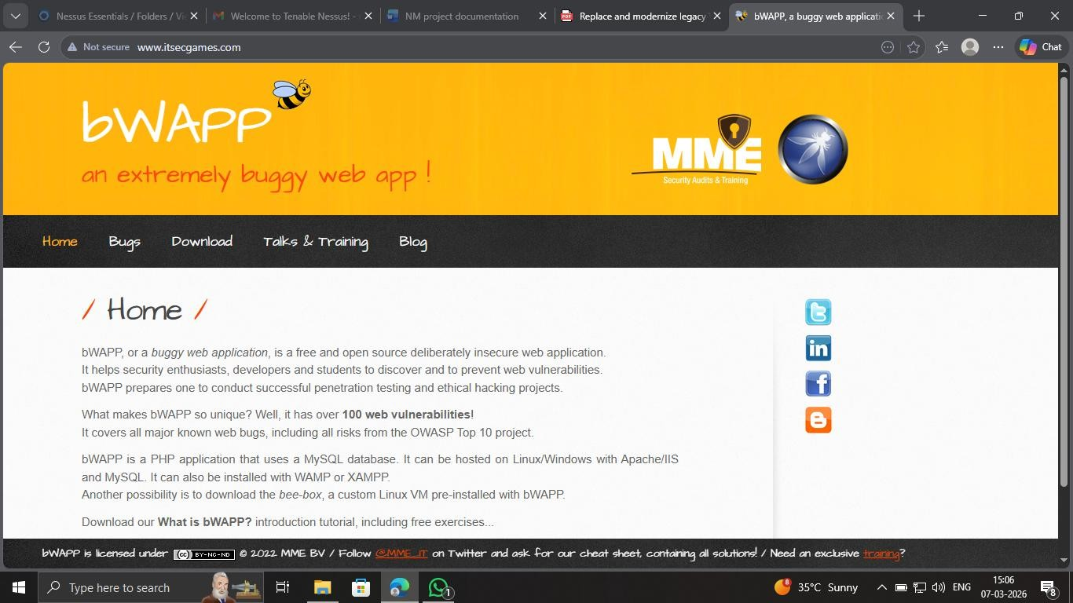
The vulnerabilities identified in this stage are based on the OWASP Top 10, which is a globally recognized list of the most critical web application security risks.

Vulnerability Details 1. Improper Sanitization of File Paths
CWE: CWE-284 – Improper Access Control
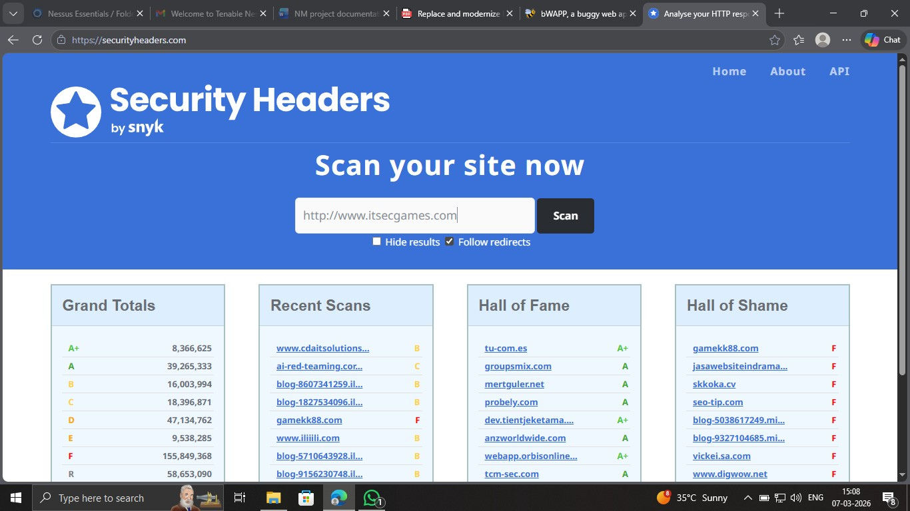
Description:
Improper sanitization of file paths occurs when a web application does not properly validate or restrict access to sensitive files or directories. Attackers may manipulate file paths to access restricted files on the server.
Business Impact:
Attackers may gain unauthorized access to sensitive files, configuration data, or private information stored on the server.
Recommendation:
- Implement strict access control policies
- Restrict file system permissions
- Regularly audit file access permissions
- Apply security updates to the web application

2. Invalid Certificate
CWE: CWE-395 – Improper Certificate Validation
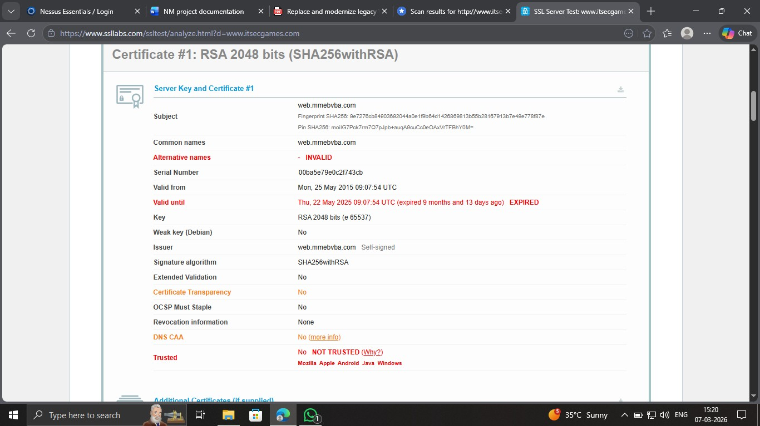
Description:
An invalid or improperly configured SSL certificate may allow attackers to impersonate trusted systems and intercept communications between users and the server.
Business Impact:
- Man-in-the-Middle attacks
- Data interception
- Unauthorized access to sensitive data Recommendation:
- Use trusted certificate authorities
- Validate certificate chains
- Implement certificate pinning
- Regularly update security certificates

3. Missing X-Frame-Options Header
CWE: CWE-1021 – Improper Restriction of Rendered UI Layers

Description:
The absence of the X-Frame-Options HTTP header allows the web page to be embedded within an iframe on another website. This may lead to clickjacking attacks where users unknowingly interact with malicious content.
Business Impact:
- Unauthorized user actions
- User interface manipulation
- Potential data theft
Recommendation:
- Implement the X-Frame-Options header
- Use Content Security Policy (CSP)
- Restrict iframe embedding

4. X-Content-Type Options Header Missing
CWE: CWE-918 – Server-Side Request Forgery
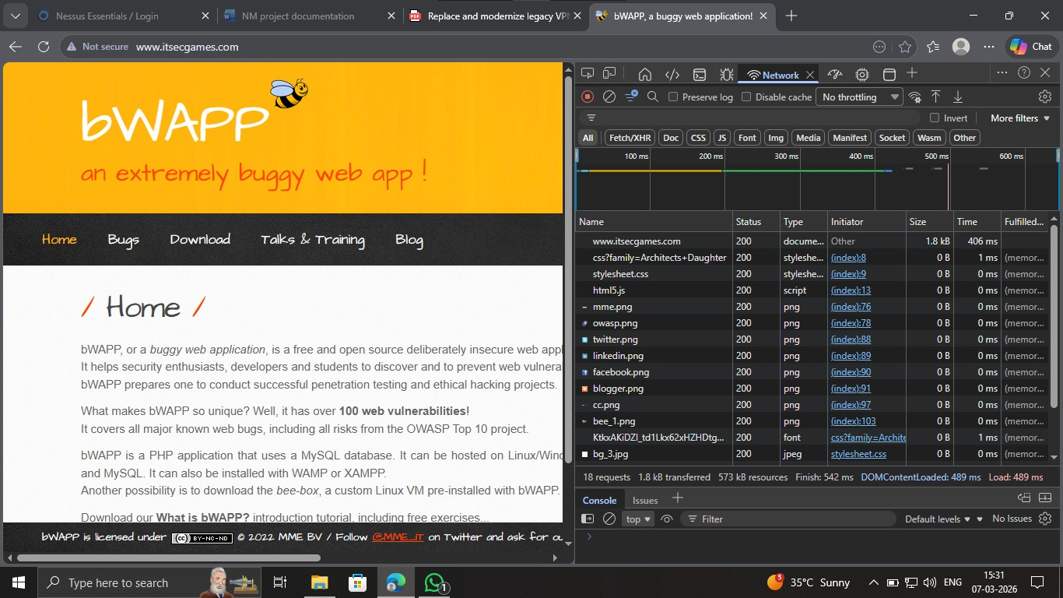
Description:
When the X-Content-Type-Options header is missing, browsers may attempt to guess the content type of files. This can allow attackers to manipulate how the browser interprets data.
Business Impact:
- Data exposure
- Security bypass
- Potential cross-site scripting attacks
Recommendation:
Add the following security header in the server configuration:
X-Content-Type-Options: nosniff

5. Drupal Ajax API Shows JSONP Not Disabled
CWE: CWE-937 / CWE-1035 – Using Components with Known Vulnerabilities
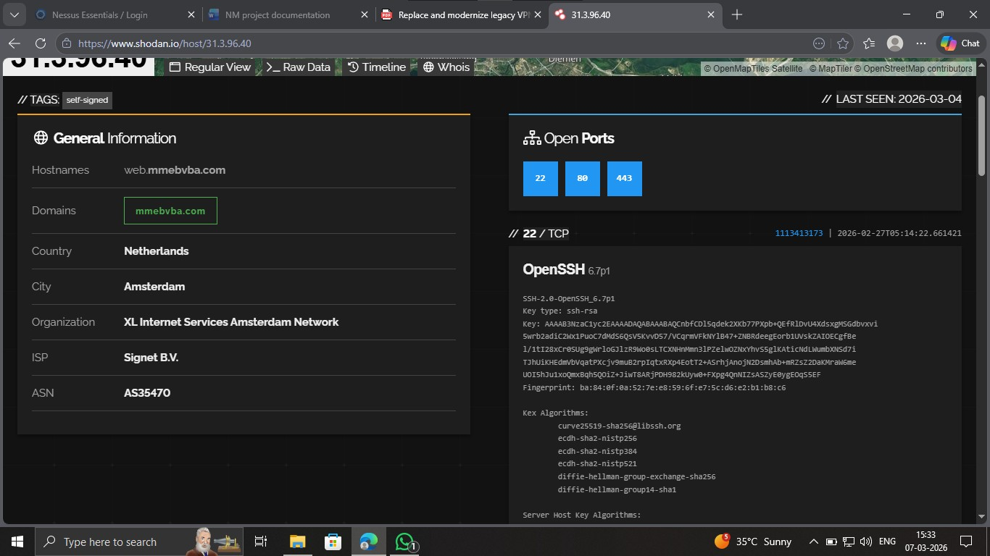
Description:
Some Drupal API configurations allow JSONP requests by default. This may expose the application to vulnerabilities when outdated components or insecure configurations are used.
Business Impact:
- Exploitation of outdated components
- Remote code execution
- Unauthorized system access
Recommendation:
- Update Drupal components regularly
- Disable unused APIs
- Perform periodic vulnerability scanning

6. Drupal API Vulnerability (Improper Input Validation)
CWE: CWE-20 – Improper Input Validation
Description:
Improper validation of user input may allow attackers to inject malicious data into the application, potentially leading to SQL injection or command injection attacks.
Business Impact:
- Database compromise
- Data theft
- System manipulation

Recommendation:
- Validate and sanitize all user inputs • Use parameterized queries
- Implement secure coding practices

7. Improper API Filtration (Cross-Site Scripting)
CWE: CWE-79 – Cross-Site Scripting (XSS)
Description:
Cross-Site Scripting occurs when a web application allows user input to be executed as a script in another user's browser.
Business Impact:
- Session hijacking
- Credential theft
- Website defacement
Recommendation:
- Encode user input properly
- Implement Content Security Policy
- Perform regular security testing

8. Denial of Service (DoS)
CWE: CWE-400 – Uncontrolled Resource Consumption
Description:
A Denial-of-Service attack attempts to overwhelm the server with excessive requests, causing the system to become unavailable to legitimate users.
Business Impact:
- Service interruption
- System downtime
- Loss of business operations Recommendation:
- Implement rate limiting
- Use Web Application Firewalls (WAF)
- Monitor network traffic for unusual patterns

9. TLS Version 1.0 Protocol Detection
CWE: CWE-327 – Use of Broken or Risky Cryptographic Algorithm
Description:
TLS 1.0 is an outdated encryption protocol that contains known vulnerabilities.
Business Impact:
- Weak encryption
- Risk of data interception
- Non-compliance with modern security standards Recommendation:
Disable TLS 1.0 and enable TLS 1.2 or TLS 1.3.

10. web.config File Information Disclosure
CWE: CWE-497 – Exposure of Sensitive Information
Description:
If the web.config file is accessible publicly, attackers may obtain sensitive configuration information including database credentials.
Business Impact:
- System compromise
- Data leakage
- Unauthorized system access
Recommendation:
- Restrict access to configuration files
- Encrypt sensitive data
- Implement strict access controls Conclusion:
The vulnerability assessment of the practice website identified several common web application security weaknesses such as improper access control, outdated cryptographic protocols, cross-site scripting, and configuration exposure. Addressing these vulnerabilities is essential to protect sensitive data, prevent unauthorized access, and ensure the overall security of web applications

Stage-2
Title: - Replace and modernize legacy VPN architectures with a cloudnative Zscaler Zero Trust solution to reduce attack surface and lateral movement.

Vulnerability Scanning Using Nessus – Overview
In this stage, a vulnerability assessment was performed using Nessus, a widely used network security scanning tool developed by Tenable. Nessus is designed to identify security weaknesses in systems, networks, and web applications by sending various probes to the target host and analyzing its responses.
The scanner works through a plugin-based architecture, where each plugin is responsible for detecting a specific vulnerability such as outdated encryption protocols, insecure configurations, or exposed services. During the scanning process, Nessus first performs host discovery and service detection to determine the operating system and running services on the target system. After identifying these services, the scanner executes multiple vulnerability checks using its database of plugins.

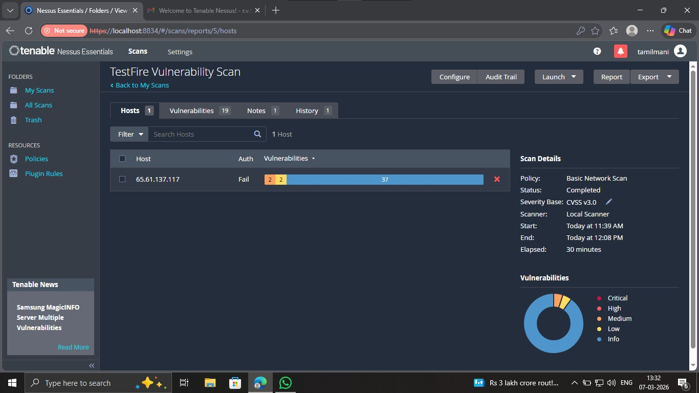

For this project, the target system selected for the vulnerability assessment was:
Target Website : http://testfire.net
Target IP : 65.61.137.117
The Nessus scan was configured using a Basic Network Scan policy, which performs a comprehensive assessment of the host by checking common network ports and identifying potential security vulnerabilities. After the scan was completed, Nessus generated a detailed report containing vulnerability findings categorized by severity levels such as Medium, Low, and Informational.
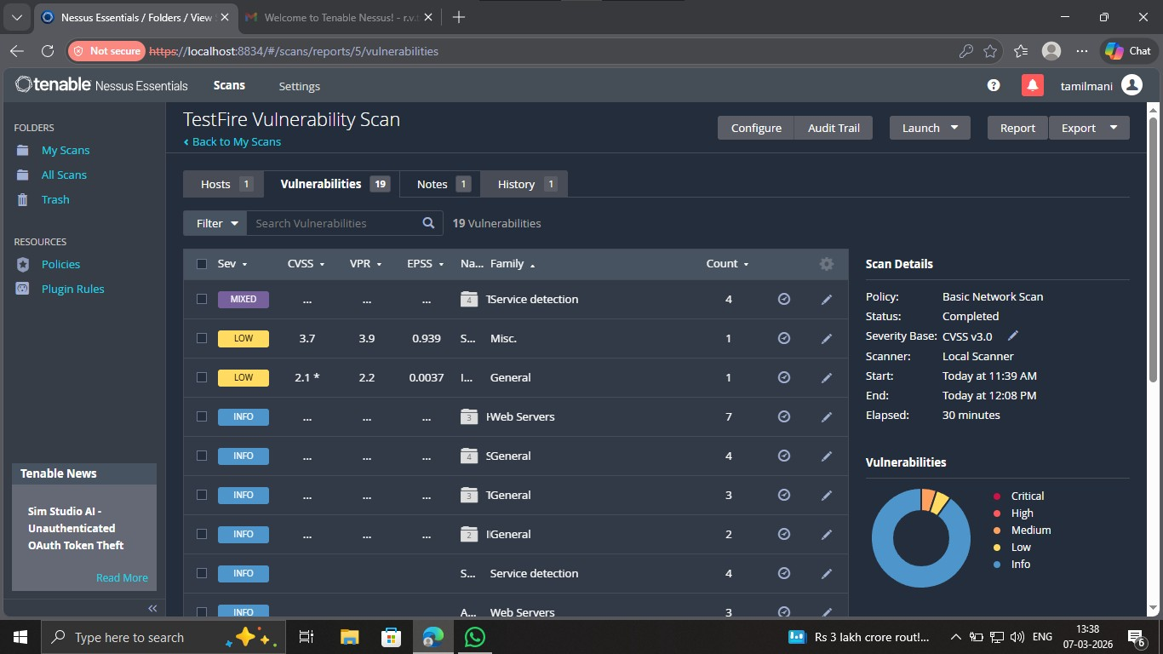
The results from the scan provided insight into several security issues present in the target system, including outdated TLS encryption protocols and server configuration information. These findings help security professionals understand potential weaknesses in the system and recommend appropriate remediation measures to improve overall security.

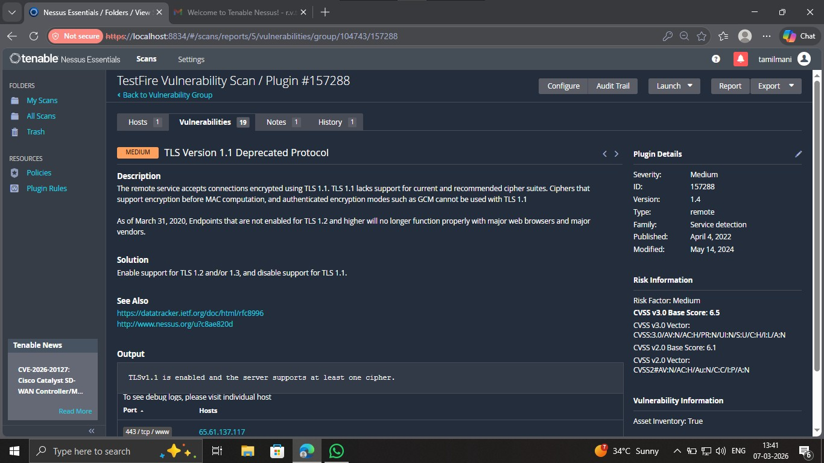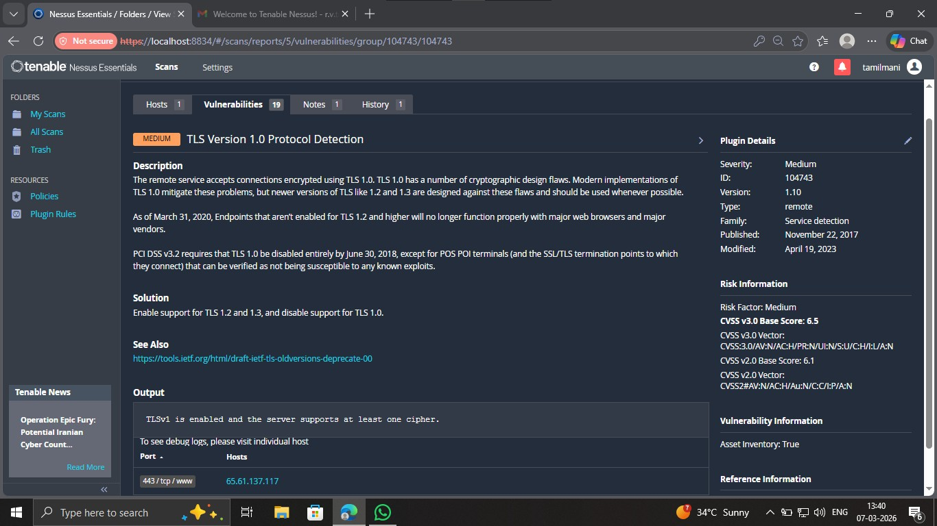
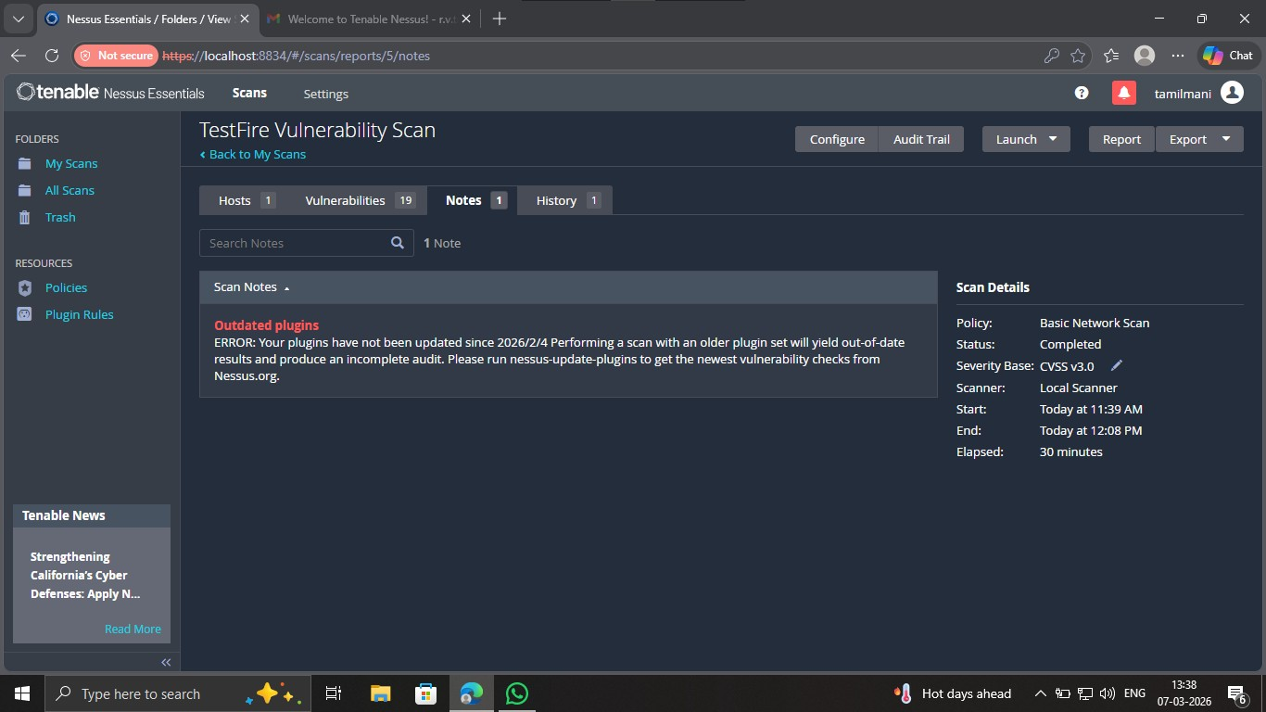
List of vulnerability:-
s.no | Vulnerability name | Severity | plugins
1. | TLS Version 1.0 Protocol Detection | MEDIUM | 104743
2. | TLS Version 1.1 Protocol Deprecated | MEDIUM | 157288
3. | SSL/TLS Diffie-Hellman Modulus <= 1024 Bits  (Logjam) | LOW | 83875
4. | ICMP Timestamp Request Remote Date  Disclosure | LOW | 10114
5. | HTTP Server Type and Version | INFO | 10107
6. | SSL Certificate Information | INFO | 10863
7. | SSL/TLS Version Supported | INFO | 56984

REPORT: -

1. TLS Version 1.0 Protocol Detection
Severity: Medium
Plugin ID: 104743 Port: 443

Description:
The remote server supports the TLS 1.0 encryption protocol. TLS 1.0 contains several known cryptographic weaknesses and is considered outdated according to modern security standards. Many modern browsers and security frameworks no longer support this protocol due to its vulnerability to attacks.
Solution:
Disable TLS 1.0 on the server and enable more secure versions such as TLS 1.2 or TLS 1.3.
Business Impact:
Using outdated encryption protocols can allow attackers to intercept or manipulate sensitive communications between clients and servers. This may lead to data breaches, loss of sensitive information, and non-compliance with modern security standards.

2. TLS Version 1.1 Protocol Deprecated
Severity: Medium
Plugin ID: 157288 Port: 443
Description:
The remote server accepts connections using TLS 1.1 encryption protocol. TLS 1.1 does not support several modern cryptographic techniques and is considered deprecated by most security standards.
Solution:
Disable TLS 1.1 and enforce the use of stronger encryption protocols such as TLS 1.2 or TLS 1.3.
Business Impact:
Allowing deprecated encryption protocols increases the risk of attackers exploiting weaknesses in the encryption mechanism, potentially exposing sensitive data during transmission.
3. SSL/TLS Diffie-Hellman Modulus ≤ 1024 Bits (Logjam)
Severity: Low
Plugin ID: 83875 Port: 443
Description:
The server supports Diffie-Hellman key exchange parameters that use a modulus size of 1024 bits or less. Weak Diffie-Hellman parameters are susceptible to the Logjam attack, which can allow attackers to downgrade encryption strength and decrypt secure communications.
Solution:
Configure the server to use Diffie-Hellman parameters of at least 2048 bits or greater.
Business Impact:
Weak encryption parameters may allow attackers with sufficient resources to break encrypted communications, exposing confidential information and compromising system security.

4. ICMP Timestamp Request Remote Date Disclosure
Severity: Informational
Plugin ID: 10114 Port: 0
Description:
The remote host responds to ICMP timestamp requests. This allows external systems to determine the system time of the target host.
Solution:
Filter or block ICMP timestamp requests and replies at the firewall level.
Business Impact:
Although this vulnerability does not directly compromise the system, attackers may use this information during reconnaissance to assist in other types of attacks.

5. HTTP Server Type and Version
Severity: Informational
Plugin ID: 10107 Port: 443
Description:
The remote web server reveals information about the type and version of the HTTP server software being used.
Solution:
Configure the server to hide or minimize server banner information by modifying the server configuration.
Business Impact:
Exposing server type and version information can help attackers identify known vulnerabilities associated with the specific server software.

6. SSL Certificate Information
Severity: Informational
Plugin ID: 10863 Port: 443
Description:
The SSL certificate details of the remote host were detected. This information includes certificate issuer, validity period, and encryption details.
Solution:
Ensure that the SSL certificate is valid, issued by a trusted Certificate Authority, and regularly updated.
Business Impact:
Although this information itself is not harmful, attackers may use certificate details for reconnaissance or identifying misconfigured certificates.

7. SSL/TLS Version Supported
Severity: Informational
Plugin ID: 56984 Port: 443
Description:
The scan detected the SSL/TLS versions supported by the remote server. This helps determine which encryption protocols are enabled.
Solution:
Disable outdated SSL/TLS versions and allow only modern secure protocols such as TLS 1.2 and TLS 1.3.
Business Impact:
Supporting insecure SSL/TLS versions can expose the system to cryptographic attacks and compromise secure communications.

Stage-3
Title: - Replace and modernize legacy VPN architectures with a cloudnative Zscaler Zero Trust solution to reduce attack surface and lateral movement. Overview
Traditional network security models rely heavily on Virtual Private Networks (VPNs) to allow remote users to access internal organizational resources. These legacy VPN architectures operate on a perimeter-based security model, often referred to as the castle-and-moat approach. In this model, once a user successfully authenticates to the VPN, they are granted broad access to the internal network.

However, this architecture is no longer suitable in modern environments where organizations support remote work, cloud services, and distributed applications. The traditional VPN model introduces several security risks, including increased attack surface and the possibility of lateral movement, where attackers move across systems inside the network after gaining initial access.

Replace and modernize legacy VP…

To address these issues, organizations are shifting toward a Zero Trust Network Access (ZTNA) architecture using solutions such as Zscaler Private Access, which is part of the Zscaler Zero Trust Exchange platform.

Legacy VPN Architecture
Legacy VPN solutions establish an encrypted tunnel between remote users and the organization’s internal network using VPN concentrators or gateway devices. Once authenticated, users are placed directly on the internal network and assigned an internal IP address.
This approach has several limitations:
- Over-permissioned access – Users gain access to the entire network instead of only the applications they need.
- Expanded attack surface – VPN gateways must expose ports to the public internet.
- Risk of lateral movement – Attackers can move between internal systems if one device is compromised.
- Poor user experience – Traffic is often routed through centralized data centers, causing latency.
- Operational overhead – Organizations must maintain VPN hardware, apply patches, and manage capacity.
These limitations make legacy VPN systems vulnerable to modern cyber threats.

The Problem: Attack Surface and Lateral Movement
One of the biggest risks associated with traditional VPN architectures is the expanded attack surface. VPN gateways expose services to the internet, making them targets for attackers who perform port scanning, credential-stuffing attacks, or exploit vulnerabilities.
Another major issue is lateral movement. Once attackers gain access to the network through stolen credentials or compromised devices, they can scan the internal network and access other systems such as file servers, databases, and application servers.
This increases the likelihood of large-scale security breaches and data exfiltration.

Zero Trust Security Model
To overcome these challenges, organizations are adopting the Zero Trust security model, which follows the principle:
Never Trust, Always Verify
In a Zero Trust architecture:
- No user or device is automatically trusted.
- Every access request must be authenticated and authorized.
- Users are granted access only to specific applications rather than the entire network.
Zero Trust eliminates implicit trust within the network and significantly reduces security risks.

Zscaler Private Access (ZPA)
Zscaler Private Access (ZPA) is a cloud-native security solution that implements the Zero Trust model. Instead of connecting users to the network, ZPA connects users directly to the applications they need.
Key features of ZPA include:
- Application-Level Access
Users connect directly to specific applications instead of the entire network.

- Identity-Based Access Control
Access decisions are based on user identity, device posture, and security policies.
- Micro-Segmentation
Each application is isolated from others, preventing attackers from moving laterally.
- Invisible Applications
Internal applications are not exposed to the internet, reducing the attack surface.

5. Secure Micro-Tunnels
ZPA establishes encrypted micro-tunnels between users and applications, ensuring secure communication.

Benefits of the Zscaler Zero Trust Architecture
The adoption of Zscaler’s Zero Trust architecture provides several advantages:
Reduced Attack Surface
Applications are hidden from the public internet, preventing direct attacks.
Prevention of Lateral Movement
Users can access only the specific applications they are authorized to use.

Improved Performance
Traffic is routed through Zscaler’s global cloud infrastructure rather than centralized data centers.
Simplified IT Operations
Organizations no longer need to maintain complex VPN hardware.
Enhanced Security Posture
Continuous authentication and authorization reduce the risk of unauthorized access.

Conclusion
The transition from legacy VPN architecture to a cloud-native Zero Trust solution using Zscaler significantly improves the organization’s security and operational efficiency. By eliminating network-level access and enforcing application-level access controls, the Zero Trust model reduces attack surface and prevents lateral movement within the network.Implementing Zscaler Private Access enables organizations to provide secure, scalable, and high-performance remote access while protecting critical applications from modern cyber threats.

